* Note
  + In this portion we shall combine JavaScript with HTML and CSS

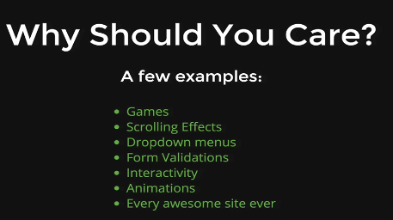

* Example:
  + <http://patatap.com/>
* Note
  + DOM is the interface between your JavaScript and your HTML and CSS
  + DOM = Document Object Model

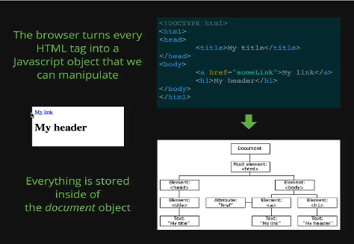

* Illustration
  + Within the illustration
    - Object Model Portion
      * We load up HTML
      * It is displayed on the browser
      * The browser takes the HTML and takes each elements
      * And make each elements into an object
    - Document Model Portion
      * The entire model of our HTML and CSS is called our document
      * Example:
        + Go to any website
        + Press “Ctrl + Shift + I”
        + Type “document”

With this we will get the HTML

* + - * + Type “console.log(document)”;
        + Result: Print out the entire document object in this object syntax we are familiar with
        + There is a lot of stuff, most things are unknown to us and this is why we google a lot
    - Object Model Portion
      * Everything lives inside this one Big object